Scrum

Scrum is a framework for project management that emphasizes teamwork, accountability and iterative progress toward a well-defined goal.

* Three phases in Scrum:

An outline planning for the project and design the software architecture.

A series of sprint cycles, where each cycle develops an increment of the system.

The project closure phase wraps up the project, completes required documentation.

☺ **The Scrum process:**

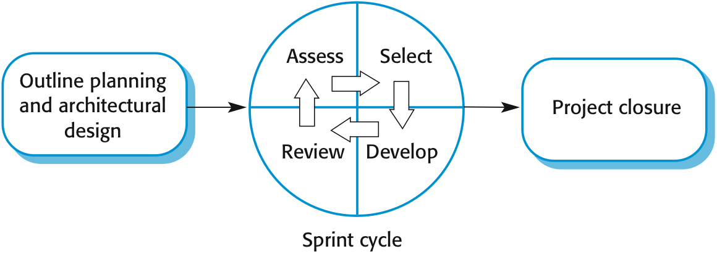

A Scrum sprint cycle is a timeboxed period when a team delivers a set amount of work. It includes task planning, performing, managing the tasks, attending daily stand-ups, and communicating with the Scrum teams. The outcome of Sprint Execution is a potentially shippable product increment, formed from a list of product backlog items by meeting the team members' definition of done.

**Teamwork in Scrum:**

A scrum team is a group of collaborators, typically between five and nine individuals, who work toward completing projects and delivering products. The fundamental scrum team comprises one scrum master, one product owner and a group of developers. Within a scrum team, there is no rank or hierarchy.

**Advantage and Disadvantage:**

|  |  |
| --- | --- |
| **Advantage** | **Disadvantage** |
| **1**. Motivated to finish the sprint. | **1.**  Losing the track of the process. |
| **2.** All team-members have the access to project progress. | **2.** Not clear defining each role. |
| **3.** The focus on quality. | **3.** No big picture of the project. |
| **4.** Easy to recognize. |  |